**Problem 1:**

A file system uses UNIX inode data structure which contains **8** direct block addresses, **2** single indirect blocks, **2** double indirect blocks and **2** triple indirect blocks. The size of each block is **32 Bytes** and the size of each block address is **4 Bytes**. Find the maximum possible file size?

**Solution:**

Total # of pointers in one data block = 32/4 =8

Total # of pointers = 8 + (2*8) + (2*8*8) + (2*8*8*8) = 1176

**Maximum file size** = 1176 * 32 = **37632 Bytes** = **36.75 KB**

**Problem 2:**

A file system has inode size = 512B and block size = 4KB. First 3 blocks contain superblock, data bitmap and inode bitmap. Now calculate the address of the inode number 23. The disk is sector addressable and the size of each sector is 256 B. Find out the sector address of the inode.

**Solution:**  
Inode start address = 3*4 KB = 12 KB  
Offset = 23 * 512 B = 11.5 KB  
**Address of inode 23 = 12 + 11.5 KB = 23.5 KB ≃ 23 KB**  
Block number = 23*512 B / 4 KB = 11.5 KB / 4 KB = 2.875 ≃ 2

**Sector address = {(2*4 KB) + 12 KB} / 256 B = 80**

**Problem 3:**

An existing file named “a1” needs to be read which is allocated in **2** data blocks.

* Path of the file: “/new/one/a1”
* To read the file it was opened first by open() system call.
* After opening the file read() system call was issued in the file to read the contents.

Illustrate the file access path timeline according to the scenario described above.

**Solution:**

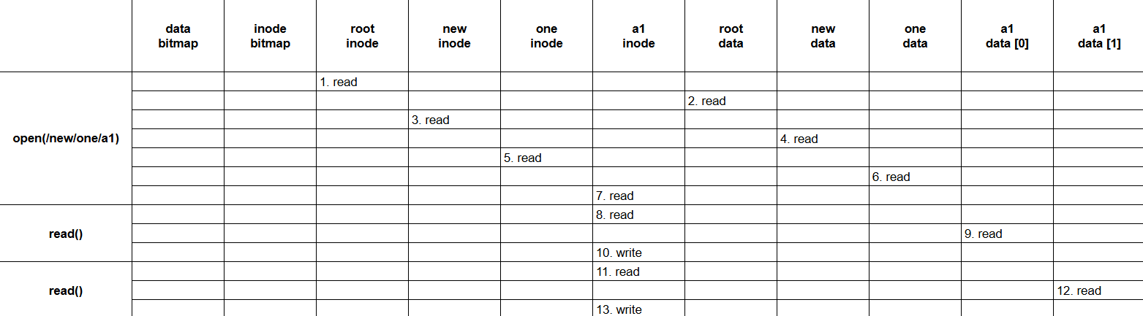

**Problem 4:**

A file named “b1.c” has been created by create() system call.

* Path of the newly created file: “/abc/def/b1.c”
* After creating the file write() system call was issued in the file to write new contents and after the write operation the file has been allocated in **4** data blocks.

Illustrate the file access path timeline according to the scenario described above.

**Solution:**

